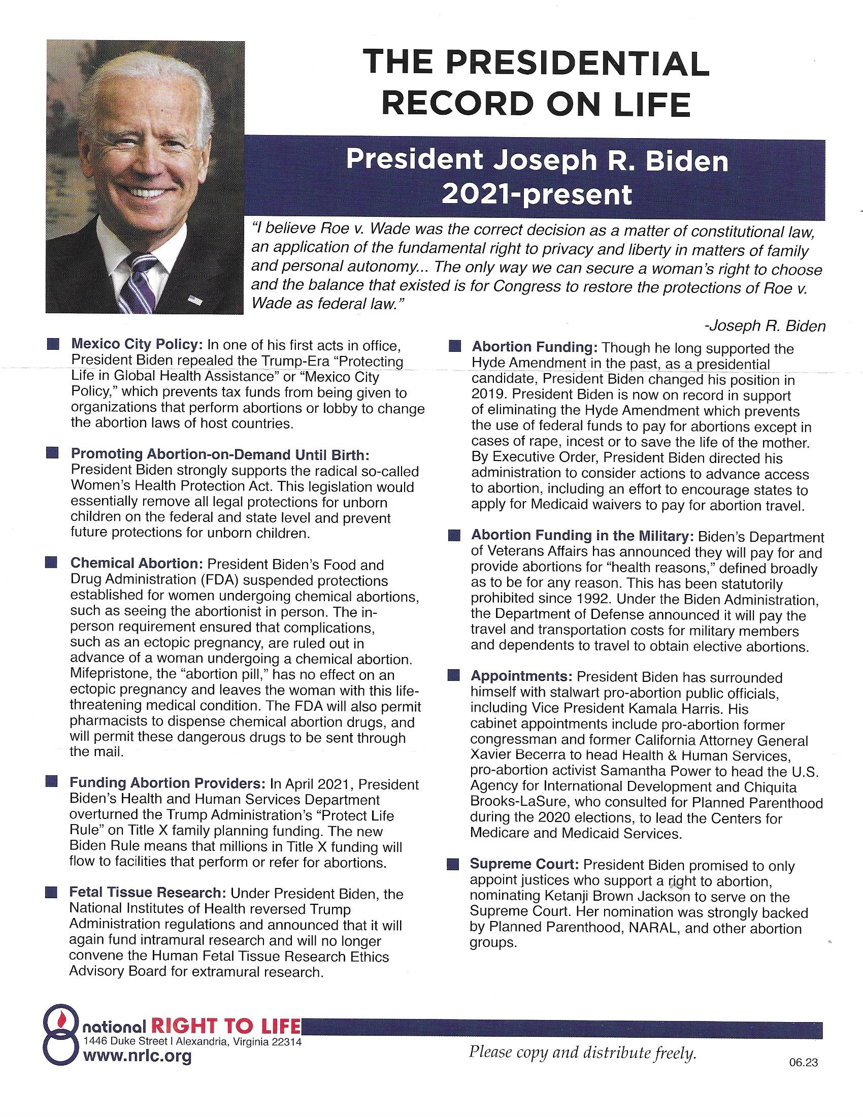

We received the following Information from National Right to Life on the Abortion Record of President Joe Biden. It shows since his first days in office as President he has pushed abortion and the funding of abortion on the American People. For Your Informaition.