The Daviess County Right to Life

Salutes the Founding Members

& Others Who Have Contributed Greatly to the founding of Daviess County Right to Life! They gave so much of their time and effort to the work of preserving life for the unborn and those unable to speak for themselves. We will always remember their contributions to the Pro-Life Movement. Even though they are no longer with us, we will never forget what they done in the early days of Daviess County Right to Life.

May God Grand Them Their Eternal Reward!

---------------------------------------

Right to Life Honor Roll

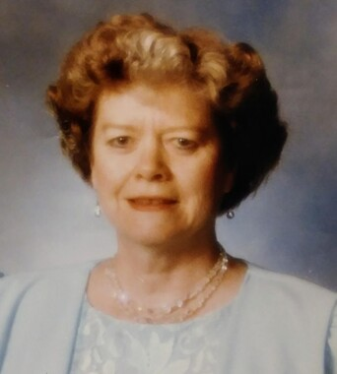

Betty Reister

Betty Snead

